**Lab Exercise - 12**

**MatplotLib Exercises**

Follow the instructions to recreate the plots using this data:

import numpy as np

x = np.arange(0,100)

y = x*2

z = x**2

Exercise 1

** Follow along with these steps: **

* ** Create a figure object called fig using plt.figure() **
* ** Use add_axes to add an axis to the figure canvas at [0,0,1,1]. Call this new axis ax. **
* ** Plot (x,y) on that axes and set the labels and titles to match the plot below:**

** Now plot (x,y) on both axes. And call your figure object to show it.**

## Exercise 2

** Create a figure object and put two axes on it, ax1 and ax2. Located at [0,0,1,1] and [0.2,0.5,.2,.2] respectively.**

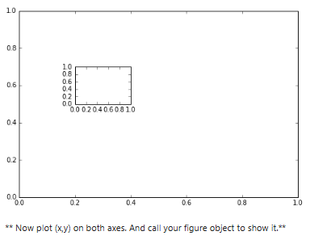

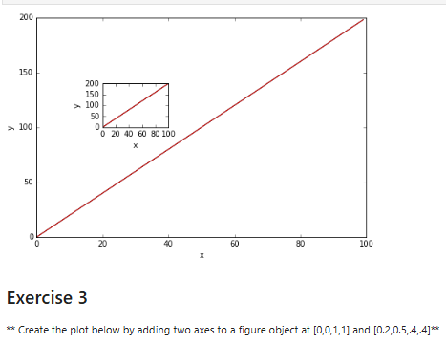

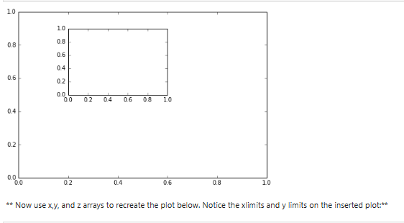

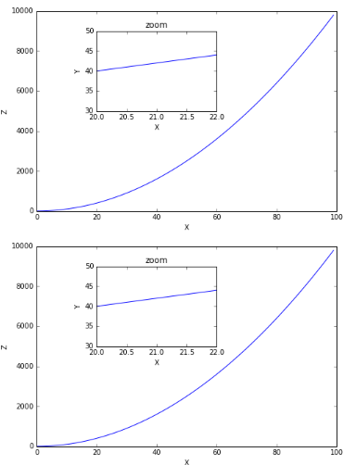

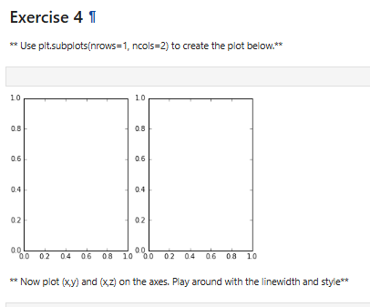

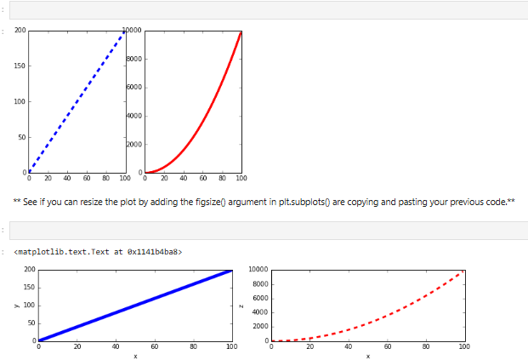

# Lab -Seaborn Exercises

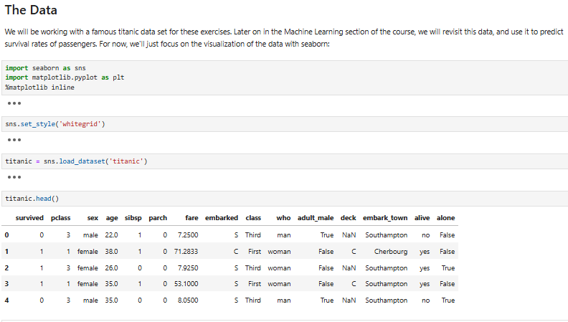

** Recreate the plots below using the titanic dataframe. There are very few hints since most of the plots can be done with just one or two lines of code and a hint would basically give away the solution. Keep careful attention to the x and y labels for hints.**

** Note! In order to not lose the plot image, make sure you don't code in the cell that is directly above the plot, there is an extra cell above that one which won't overwrite that plot! **

